OBJECTIVE

The objective of this tutorial is to provide an overview of the ‘recommended’ Word format for ‘publishing’ to the Users’ Knowledge Base (UKB) by attachment. It also doubles as the ‘test piece’ for pasting a Word document into Windows Live Writer at: AmiBroker Users’ Knowledge Base » Converting Word Documents Into Posts

INTRODUCTION

The majority of posts can be written using four elements: formatted text, images, tables and hyperlinks. If attached documents are restricted to these basic features, most users will be able to easily view them as written, irrespective of their word processing software. Advanced features, like newsletter columns, indexing, table of contents, document maps etc can be used, but they will not be available to all.

For additional information on posting with attached documents refer to: AmiBroker Users’ Knowledge Base » Quick Posting

SPECIFICATION

This document was written using Microsoft Word 2002 and Excel 2002 on a computer with Microsoft XP Home as the operating system and Internet Explorer 7 as the web browser.

INSERTING THE BASIC FEATURES

Images

To Insert Images:

1) Go to Insert > Picture > From File on the menu bar.
2) Pick an image from the file browser that opens and click on Insert (the selected image will be pasted into the document at the location of the cursor).

Figure 1
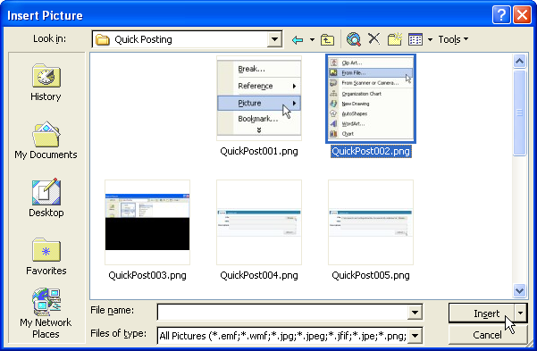

To Format An Image:

1) Right click on the image in the document.
2) Select Format Picture from the context menu that opens.

Figure 2
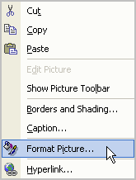

3) Format the image using the options available.

Figure 3
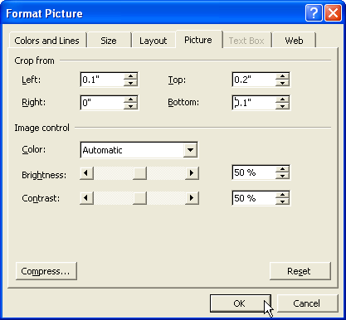

Note: Resizing pictures is not recommended as it will affect the clarity of the image, although sometimes it is unavoidable. A better result is obtained if the width of all image captures is smaller than the width of the document. (The document width will vary depending on the paper size selected and the margin settings. Typically it is approximately 6.5 inches for a ‘letter’ document using 1” margins).

Tables

To Insert Tables:

1) Go to Table > Insert > Table from the menu bar.
2) Set the table specifications using the Insert Table window that opens.

Figure 4
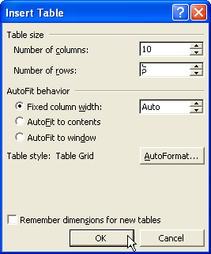

3) Click on OK and the table will be pasted into the document at the location of the cursor.
4) Move between cells using the Tab key, or the arrow keys on the keyboard, and manually enter data into each cell as required.
Table 1
A | B | C | D | E | F | G | H | I | J
1 | 2 | 3 | 4 | 5 | 6 | 7 | 8 | 9 | 10

To Format Tables:

1) Right click on the table and change formats using the context menu that opens.

Figure 5
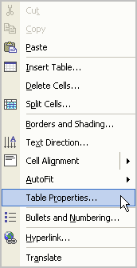

2) Select Table Properties to access some additional table settings.

Converting Tables To Images

Word documents can be converted to HTML posts by copying and pasting into Windows Live Writer (WLW) for uploading to the UKB. The features recommended in this example all convert to HTML, without any problems, except for tables. To get around this, tables need to be converted into images in Word before transferal to WLW.

To Change A Table Into An Image:

1) Click on any cell in the table to insert the cursor into the cell.
2) Go to Table > Select > Table from the menu bar (all of the cells in the table will change color to indicate that the table is selected).
3) Right click inside the selected area and pick Copy from the context menu that opens.
4) Position the cursor in the document, where the ‘copy’ of the table is going to be placed, and click on Edit > Paste Special from the menu bar (the Paste Special window will open).
5) Pick Microsoft Word Document Object from the scrollable list and click on OK.

Figure 6
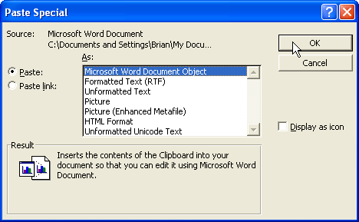

The table will be inserted as an object.
Figure 7
The original table can be deleted.

To Delete A Table:

1) Position the cursor inside any cell by clicking on it (this ‘selects’ the table).
2) Go to Table > Delete > Table from the menu bar.

Copying Tables From A Spreadsheet

Worksheets from Excel, or parts of a worksheet, can also be copied into Word as a table.

To insert a worksheet as a table:

1) Select all of the cells in a worksheet (or the required area).
2) Right click inside the selected area and Copy using the context menu that opens.

Figure 8
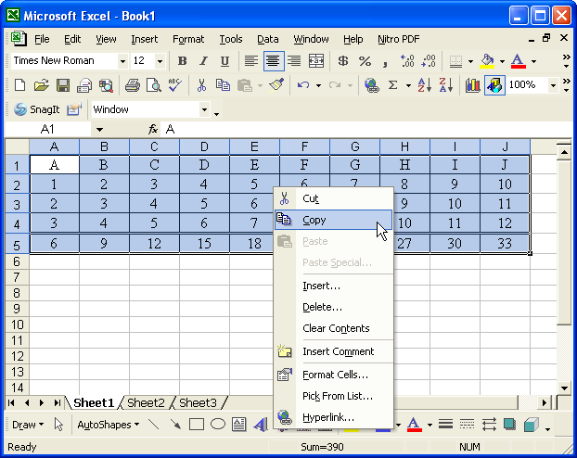

3) Position the cursor in the document where the ‘table’ is to be inserted and select Edit > Paste Special from the menu bar (the Paste Special window will open).

Figure 9
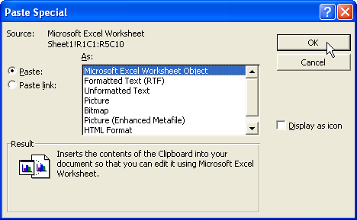

4) Select Microsoft Excel Worksheet Object and click on OK (the spreadsheet ‘table’ will be pasted into the document as an image).

Figure 10

Note: It is not a dynamic spreadsheet. To share dynamic spreadsheets, with other users, attach them to a post.

Hyperlinks

To Insert A Hyperlink Using A Shortcut Method:

1) Browse to the relevant web-page.
2) Select the URL from the browser address box.

Figure 11

3) Right click inside the selected area and pick Copy from the context menu that opens.

Figure 12
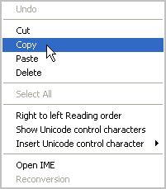

4) Position the cursor in the document, where the link is going to be placed, and right click ( a context menu will open).

Figure 13
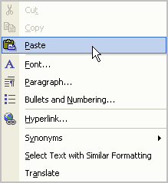

5) Paste the copied address into the document and hit enter to activate the link e.g. http://www.amibroker.com/

Note: links to related UKB posts can also be inserted using this method, although it makes for a very long link.

To Insert A Hyperlink Using The Browser Window:

1) Follow the Insert > Hyperlink path, from the menu bar, to open the Insert Hyperlink window.
2) Use the Browse the Web icon to open Internet Explorer and browse to the required web-page.

Figure 14
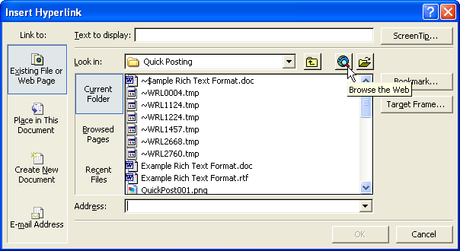

3) Leaving the web-page open return to the Insert Hyperlink window by minimizing the web-page (the web-page address will now be in the Insert Hyperlink window Address box).
4) Enter a custom title for the link, into the Text to display input box, and click on OK..

Figure 15
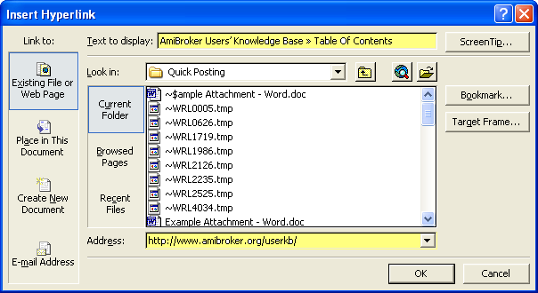

A link to the open web-page will be inserted at the current cursor location e.g. AmiBroker Users’ Knowledge Base » Table Of Contents

5) Close the web-page that was used to create the link.

To Use An Alternative Browser Window Method:

1) Select Existing File or Web Page > Browsed Pages, in the Insert Hyperlink window, and pick the required address from the scroll list that is available.

Figure 16
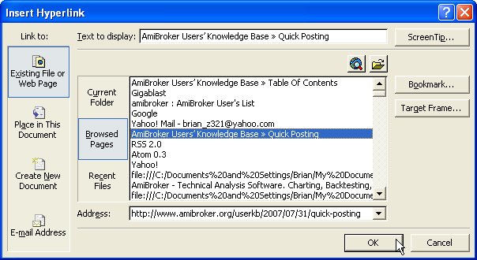

2) Click on OK and a link to the selected page will be inserted into the document e.g. AmiBroker Users’ Knowledge Base » Quick Posting

AFL Formulas

To insert AFL formulas:

1) Open the required formula in AmiBrokers’ Formula Editor.
2) Click on Select All from the Edit menu.

Figure 17
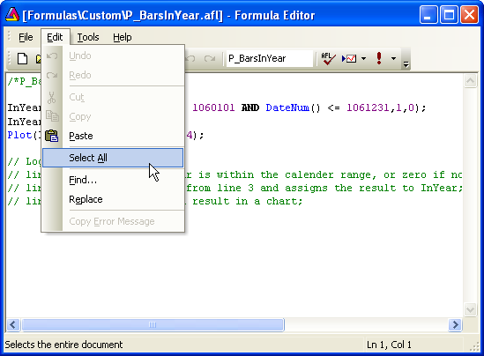

3) Right click inside the selected area and pick Copy from the context menu that opens.

Figure 18
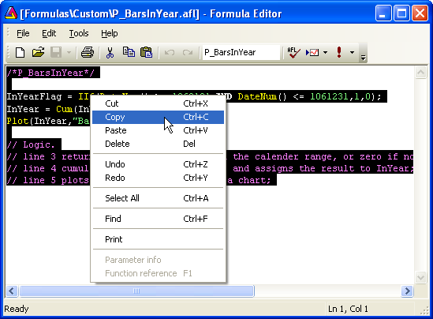

3) Right click inside the document, where the formula is to be inserted, and click on Paste.

/*P_BarsInYear*/
InYearFlag = IIf(DateNum() >= 1060101 AND DateNum() <= 1061231,1,0);
InYear = Cum(InYearFlag);
Plot(InYear,"BarsInYear",2,2|4);
// Logic.
// line 3 returns one if a bar is within the calender range, or zero if not, and assigns it to the InYearFlag variable;
// line 4 cumulates the ones from line 3 and assigns the result to InYear;
// line 5 plots the cumulated result in a chart

If the document is going to be used as the template for a WLW post, the Formula Editor preferences, in AmiBroker, need to be set to copy as plain text first.

To change the Formula Editor copy preferences:

1) Go to Tools > Preferences, on the menu-bar and click on the Editor tab.
2) Uncheck Copy as HTML by clicking on it (this will set the Formula Editor to Copy as plain text, which is the default).

Figure 19
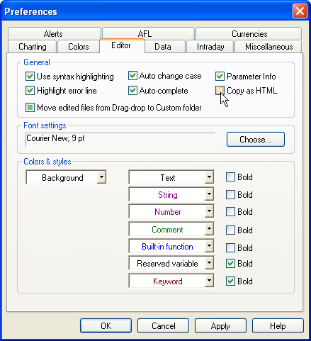

3) Click on Apply and OK to close the window.

Formulas can now be copied from the Formula Editor window, into Word documents that are destined for WLW, without any future conflict.

Adding Captions

Captions can be entered for each image, or table, as an optional extra. They are useful when referencing tables, or images, within text. They also allow users to see if any images are missing from the copy when it is opened in a program other than Word or in a low level Microsoft word processor.

To Add Captions:

1) Open the Caption window using the Insert > Reference > Caption commands from the menu bar.
2) Chose between Figure or Table from the drop-down menu and click on OK (this will insert a caption at the position of the cursor).

Figure 20
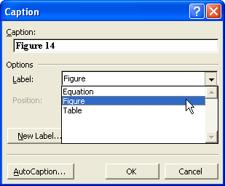

Note: The numbers are automatically sequenced, starting from the top of the document, including when an image is interposed into an established sequence .

Alternatively, right click on the image, then select Caption from the context menu that opens (the Caption window will open).

Figure 21
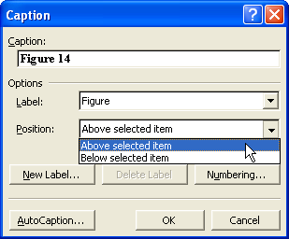

This option allows users to choose where to position the caption relative to the image (above the selected item or below selected item).

Conclusion

That ends this tutorial that introduces users to the basic skill-set required for posting to the UKB, via an attached Word document. For additional information and detailed instructions on using formatted text, images, tables, hyperlinks and captions in Word refer to the Word help manual.

